Sandeep

Shrestha

## **Student id NO: 16418526** Assignment1: Web Development

## GitHub URL:

## <https://github.com/Mathoy-James/csy1018->

## assign1.git

## Submission Date: 8/04/2017

Contents

1

Contents 2

Preliminary Stage 3

Designs 4

Wireframes 4

Home 4

Biography 4

Contact 5

CV 5

Development Environment  6

Attraction of pages 7

validation 7

Progress of website 9

Weeks 1 9

Weeks 2 8

Weeks 3 10

Final view of webpage 12-15

Things that could be improved 16

Refrences 16

Preliminary Stage

At the commencement of my assignment, I visited different websites and gained knowledge of how the portfolio looks like. Then I picked some of them which could be useful for making my website. I collected different stock images and icons from sites bixabay and pixels. I also went through API fonts provided by google to use it in my website.

1. <https://joel.sh/>

-Collected some information about how the portfolio looks

1. <https://fonts.googleapis.com/icon?family=Material+Icons>

-Used googleapi fonts

3) <https://www.pexels.com/>

-Used free stock images

Designs

Here are the wireframes for my webpages.

1. This is the wireframe for home page:

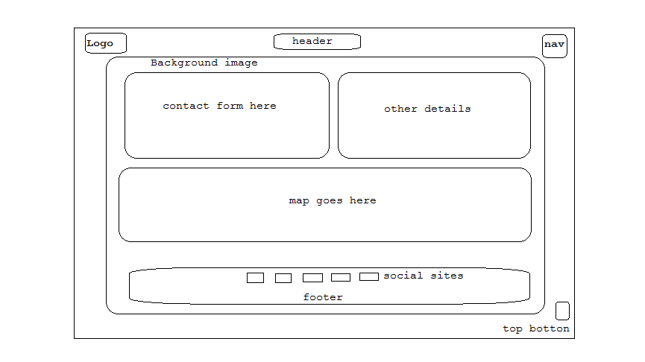

1. This is the wireframe for biography page:

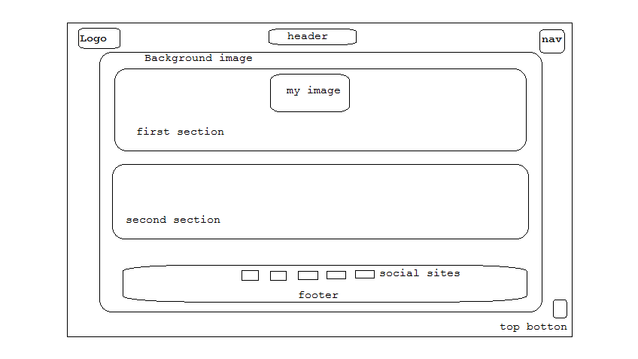

1. This is the wireframe for cv page:

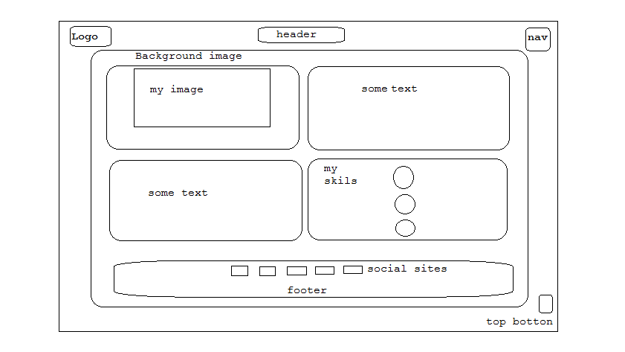

1. This is the wireframe for contact page:



Development environment

For the development of the web pages I used atom as development environment. And used github to store on web.

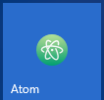 

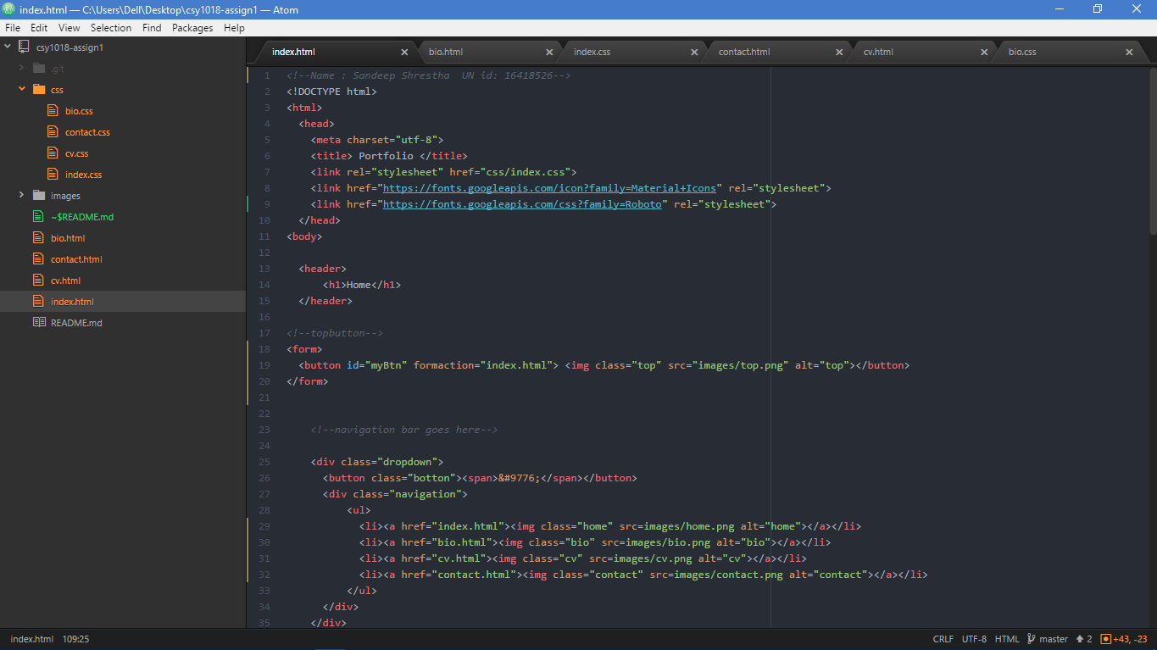

Attraction of pages

I used different images in the background which beautifies the pages. Header and footer is used in every pages. The logo is placed at the top-left of every pages which is eye catching. The navigation is easy using the button at the top-right which brings the dropdown. Navigation icons are used which navigates easily to different pages. Social media icons are in the footer part which redirects the visitor to the social media sites to visit my profile. There is a got to top button in every pages at bottom-right which takes the user to top of the page.

Validation

The validation of HTML and CSS codes are done using validator:

1. <https://validator.w3.org/> for HTML

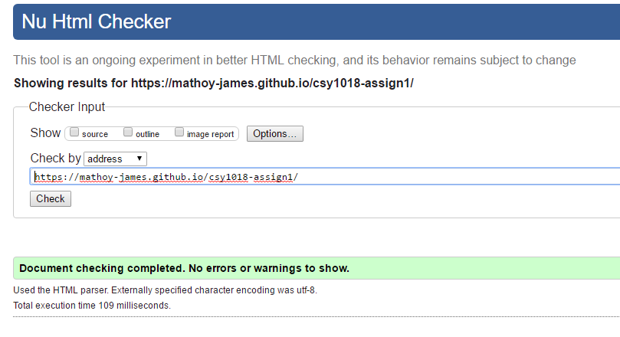

1. <https://jigsaw.w3.org/css-validator/> for CSS

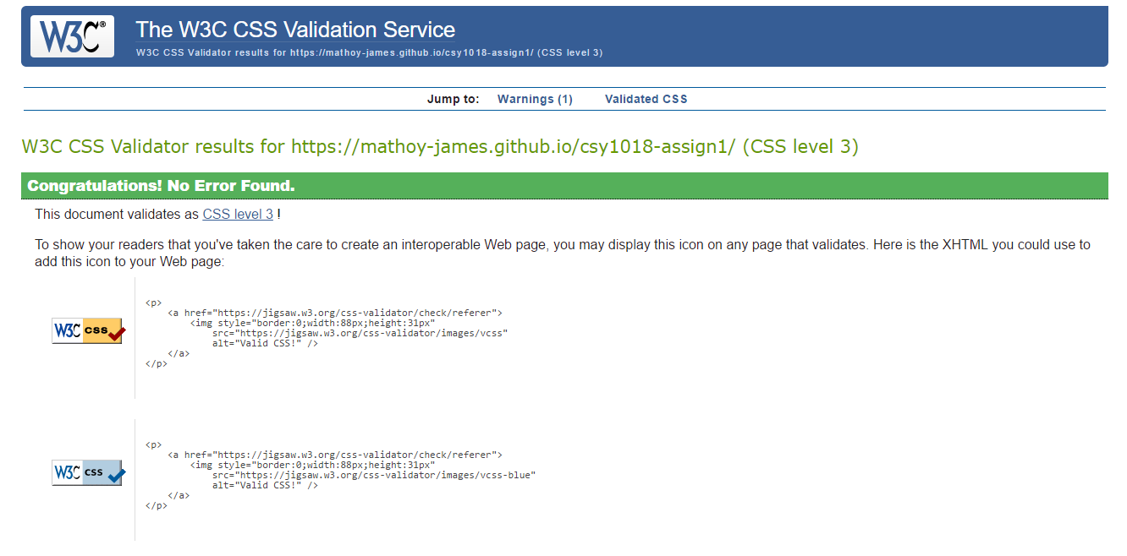

Progress of website

Week 1)

In the beginning of first week I came up with one idea and made the page like this:

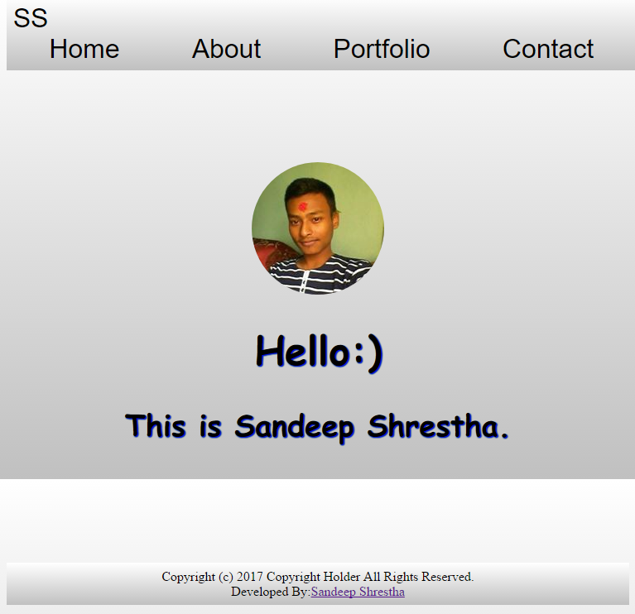

Then I changed my mind to change this to a bit different keeping a button for navigation and changing the background and content too and made it look like this:

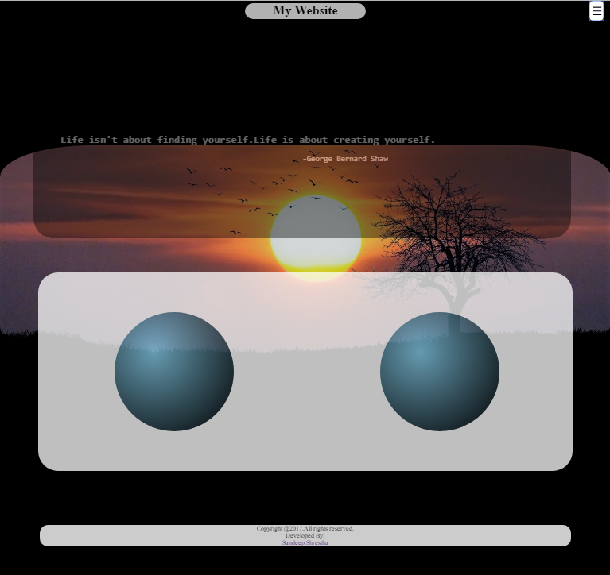

Week 2)

After finishing the design of home page I started with contact page. There I made different sections where first section contains static form, second section contains my contact s like phone, email and address. I also added a section for google embedded map of my location. For the CV page I made different sections for education, course studying now and my skills. For the bio page I designed the page which contains sections containing my biography. Then the pages looked like this:

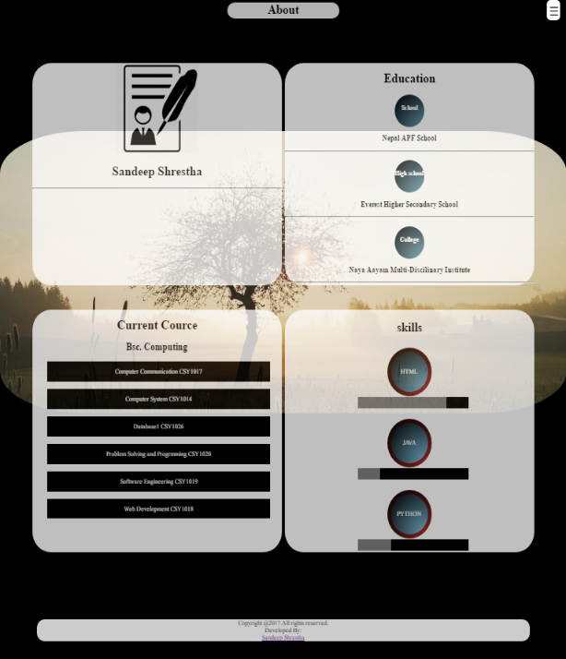 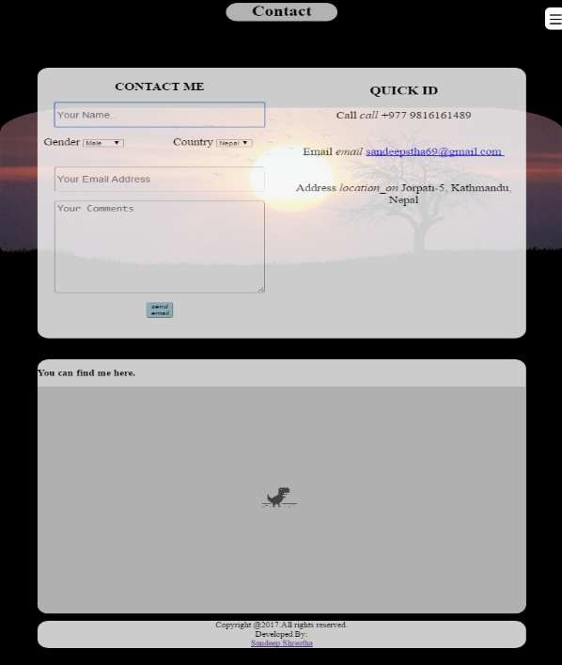

Week 3)

Finally after designing all pages I used google API font. I also added a logo at the top-left which changes its color timely. At the last I made the all pages responsive to be compatible in different screen sizes.

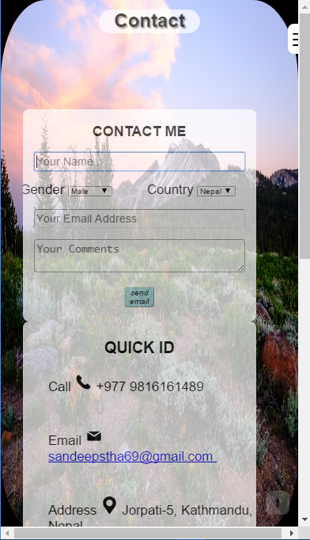

Final view of the web pages

Home page

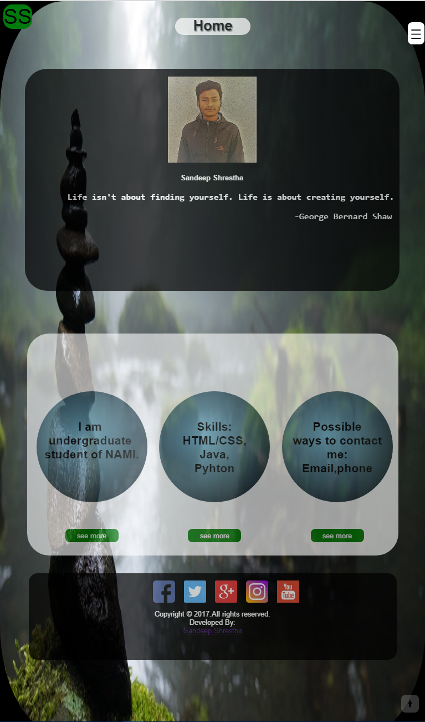

Bio page

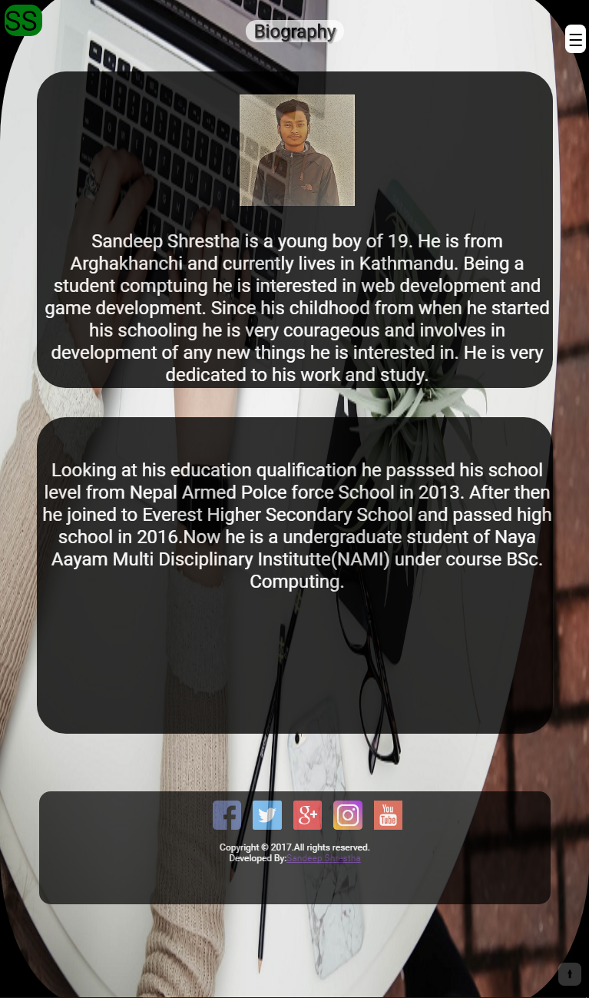

CV page

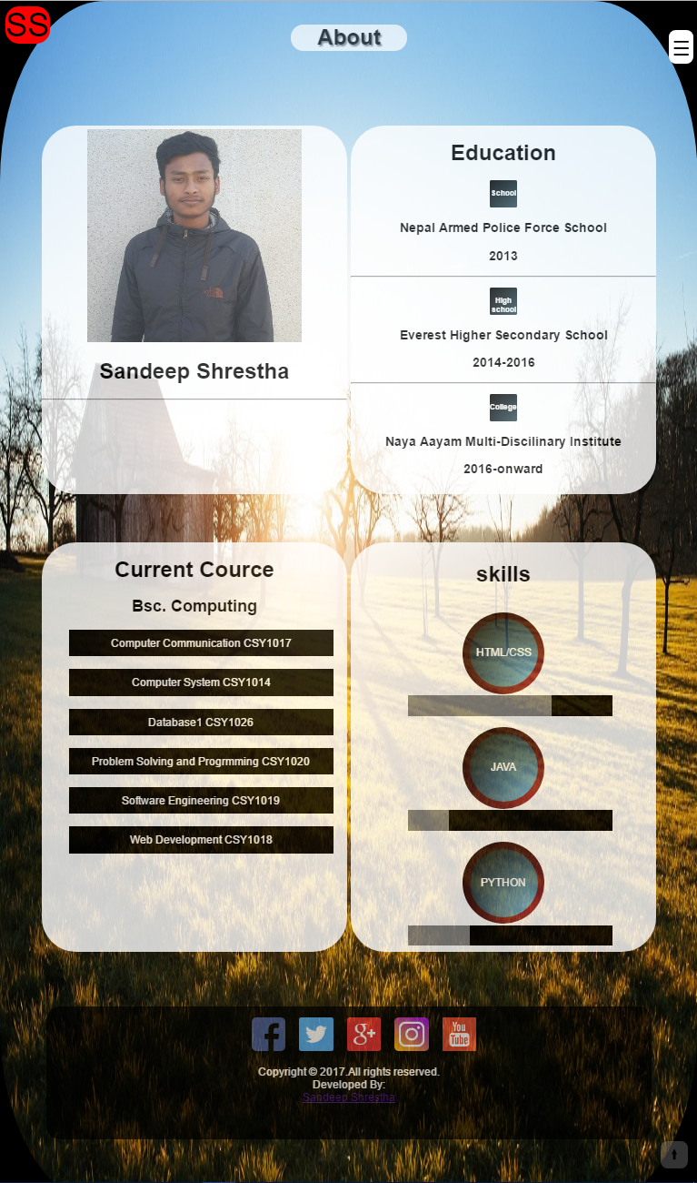

Contact page

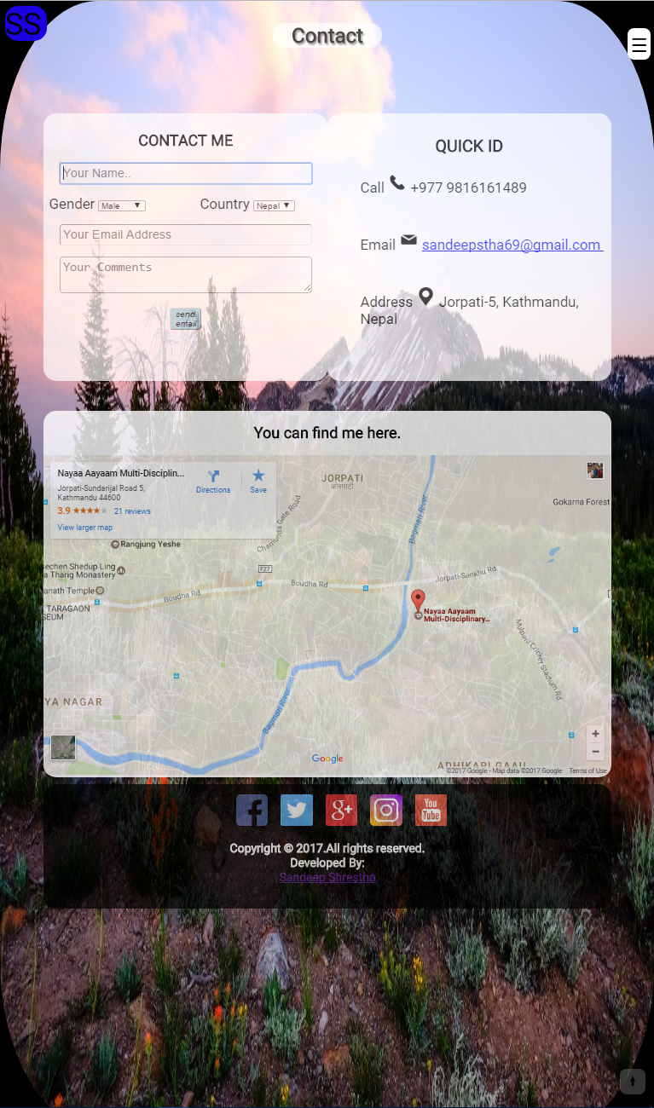

Things that could be improved

I hope that I mostly covered all the things but there are some things like responsiveness of the page is not very good. Second thing is the web pages does not load correctly in all the browsers like the list of current course list in CV page does not separate in Mozilla Firefox which loads in Chrome.

Reference

1) Pixabay(2017) Free images on Pixabay. *Pixabay*[online].Available from: <https://pixabay.com/en/photos/> [Accessed 4th April 2017]

2) Stanford,J.(2015)Joel.sh.NileNorthampton[Online]. Available from:https://joel.sh [Accessed 1st March 2017].

3)w3school(2017) W3schools.com. *W3schools*[online]. Available from: https://www.w3schools.com/w3css/tryw3css_templates_dark_portfolio.html [Accessed 26th March 2017]

4) Google Fonts (2017) Google Fonts. *Google Fonts* [online]. Available from: <https://fonts.google.com/specimen/Roboto> [Accessed 29th March 2017]

5) Pexels.com (2017) Pexels.com[online]. Available from: <https://www.pexels.com/> [Accessed 24th March 2017]